MTH 200 | Blended Session 1

Directions: Solve all problems on a separate sheet(s) of paper. Place your name on the pages you submit. You must show all of your work to receive full credit on problems. You must write complete sentences when asked to show/prove something or provide an explanation/justification. You are encouraged to work with others, consult sources, use calculators, etc. However, only submit solutions that you fully understand. Do not submit solutions which are copied from a friend or another source.

Challenge Questions

- Determine the point in the xy-plane where the line with slope 2 and y-intercept 1 intersects the line passing through the points and .
- The function f has the property that and the tangent line to its graph at passes through the point . What is ?
- Compute the limit
- Is there a value of a such that exists?
- If for all x, determine
- Determine the horizontal and vertical asymptotes to
- Let C be the ellipse . How can one use the IVT to show that there is point P on C such that the area of the triangle determined by and C is . Hint: How does the area of the triangle change as one chooses different points on C?
- Show that there exists a rectangular box with edges of length , , and for some positive value x so that the volume of the box is equal to its surface area (assume the box has both a top and a bottom).

- Give an example where and are increasing at but is decreasing at .

- Is the following function continuous at ? Justify your answer.

- A farmer is going to use fence to make a pen shaped like cutting a circle in half and inserting a rectangle.
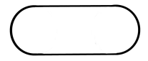

If the pen is to have an area of, how should he make the pen to minimize the amount of fence needed?

- Indicate on the graph where the first two interactions of Newton’s method will lie if one starts with the indicated value a. Then explain why a would or would not be a good starting point to approximate the root of the function.
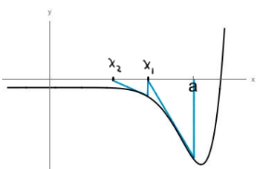

- Consider the definite integral .
- Sketch what is graphically represented by this integral.
- Use geoetmry to calculate this integral.
- Show that this integral equals 12 using the limit definition of the definite integral.

- Consider the definite integral .
- Compute the value of the integral using geometry.
- Compute the value of the integral using the FTOC.
- Compute the value of integral using the limit definition of the definite integral.

- Consider .
- Set your calculator to a standard 10x10 graphing window. What does the graph of this function suggest the limit would be?
- Zoom in on the graph near . What does the graph now suggest is the value of the limit?
- What does the table of function values suggest for the value of the limit?

- Consider .2
- Set your calculator to a standard 10x10 graphing window. What does the graph of this function suggest the limit would be?
- Zoom in on the graph near . What does the graph now suggest is the value of the limit?
- Use the fact that to evaluate the limit in this question. Hint: multiply the numerator and denominator by .

- Consider . Since we are consider the limit as x decreases without bound, we will want to zoom out and consider larger and larger negative values on the x-axis.
- As you initially begin to zoom out on the graph (values between and 0), what do you believe the value of this limit is? What is initially suggest by the table of values?
- What does the graph suggest about the limit when you consider values in the range to ? What does the table of values suggest?
- Continue to zoom out beyond . What do both the graph and the tale say is the limit for these larger values?
- Algebraically determine the correct value of the limit. Hint: consider multiplying by a “fancy 1”.

- Based on the above problems, explain why we should be cautious when using technology to evaluate limits.

- Based on your above observations, explain why we need to develop mathematical techniques to evaluate limits.

Implicit Differentiation

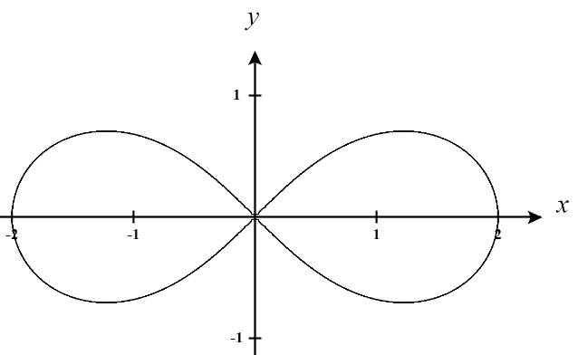
- The lemniscate shown below is described by the equation and is used in typography to denote infinity

- Find for points on the graph.
- Are there any points on the curve for which is undefined?
- Determine the equation for the tangent line at the point

- True or False? The tangent line to the function (shown below) is horizontal when .

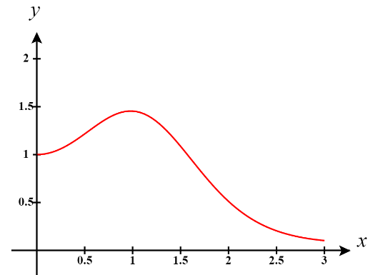

Optimization maxes/mins

- If a tank holds
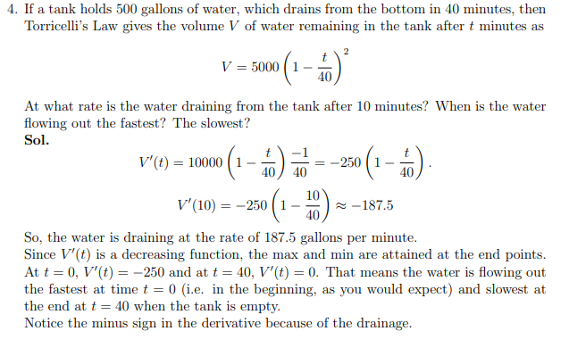

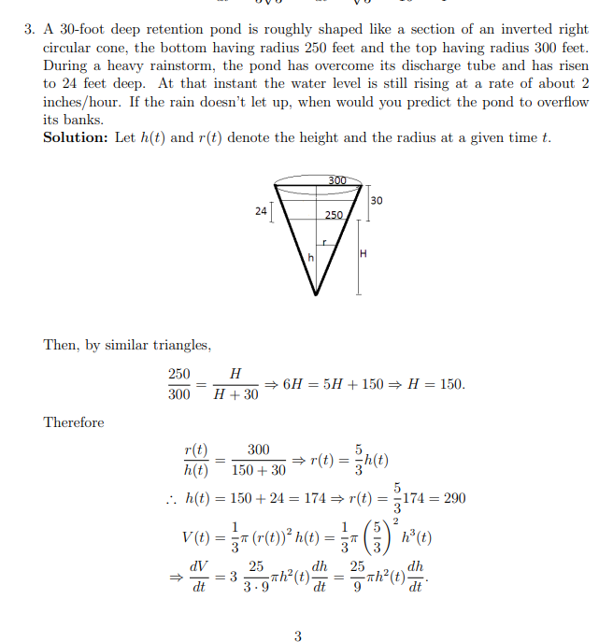
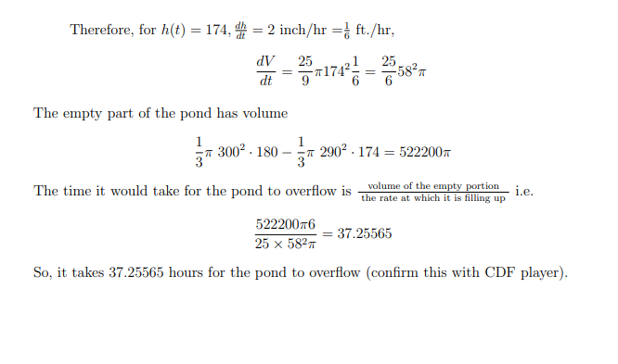
- Consider the function where a and b are real numbers.
- Find values of a and b such that has a local extreme value of 1 at .
- Determine whether the extreme value is a local minimum or maximum.

MVT, ROLLES, FERMATS

- A person begins cycling from home at noon. She begins cycling quickly and travels 3 miles norther. Then she makes a U-turn without stopping, and then cycles home slowly. She finishes cycling after 30 minutes. Let be a function that represents the total distance traveled versus time.
- Construct and label a possible graph of .
- Construct a line segment on the graph from part (a) from the starting point to the ending point. On the graph, label the point c guaranteed by the appropriate theorem.
- Refer to the cycling context of the problem to describe what the point c means in the problem.

- Let .
- If and , what value c satisfies the conclusion of the MVT?
- If and , what value c satisfies the conclusion of the MVT?
- If and , what value c satisfies the conclusion of the MVT?
- In general, what value c do you anticipate satisfies the conclusion of the MVT for any a and b with this polynomial?
- Suppose that . Show that the number c that satisfies the conclusion of the MVT for any polynomial is given by
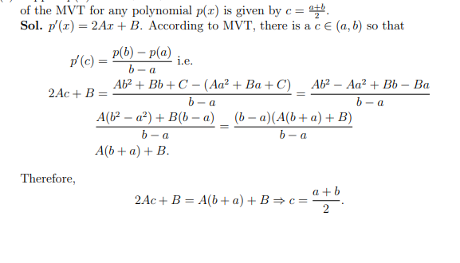

LHOPITALS

- Find each of the following limits.

- Consider (for any n). Determine the possible values of this limit for all possible values of n. Hint: Consider breaking this into cases where you look at different ranges of values for n.
- Evaluate the limit

- A metal cable has radius r and is covered by insulation, so that the distance from the center fo the cable to the exterior of the insulation is R. The velocity v of an electrical impulse in the cable is given by .

- Determine . What does this limit mean in the context of the scenario?
- Determine . What does this limit mean in the context of the scenario?

INTEGRALS AND AVERAGE VALUES
- Compute the following limit

Note that

We note that . Therefore, we have that

